Call for participants for international training

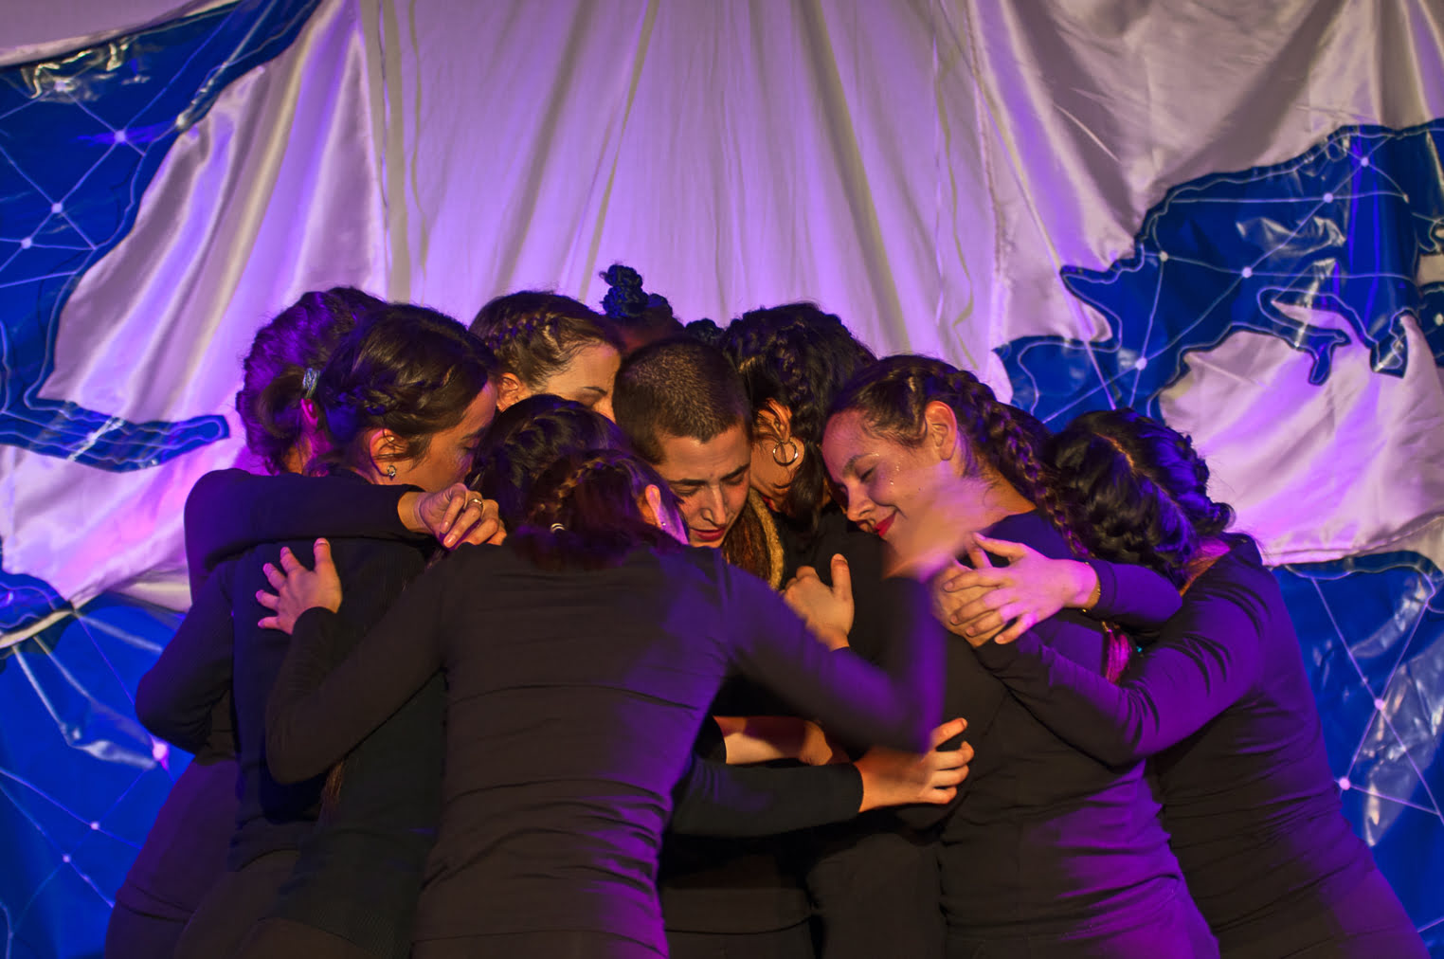
Young Activists Performing Peace
Sievershausen / near Hannover / Germany 23.07.-30.07.2024
Age 18 + / Language: English
“Theatre allows us to inform ourselves, to position ourselves, to put a voice of protest, to raise awareness, to take reality to another dimension, to dream utopias, to remember and not to forget. And above all, not to ignore conflicts”.
For all those active in youth work and youth political education:
🌈 Ready to dive into a world of change, fun, and making a difference? Imagine using the power of theatre to shake things up and build a world full of peace and understanding!
🎭 Welcome to our Youth Peace Revolution through Theatre! It's not just any workshop – It is a journey to connect with our biographies, bodies and share a space of empowerment and resilience.
Why theatre, you ask? Because it's not just about acting; it's about making noise, raising awareness and dreaming big! We're here to share the tools of Theatre of the Oppressed, Epic Theatre, Biographical Theatre, and more. Get ready to unleash your creativity in your mind and with your body!
Here you have all the information about what awaits you in our sessions:
- Let’s build a group trough Acting and Introduction to our topics. Let's talk about peace and build a tight-knit crew.
- Biographical Theatre - Let’s share our biographies and identify trough theatre tools what we have in common and with what kind of conflicts we are confronted.
- Dive into Theatre of the Oppressed – How to identify privileges and disadvantaged? Let’s talk about solutions:
- Epic Theatre – How to break the fantasy in the theatre to invite the audience to reflect on certain topics?
- Get moving with Corporal Expression – explore the connection between your body, conflicts, and peace.
- Join forces in a group project – time to put everything you've learned into action on stage.
- Individual project – show us how you'll bring the peace vibes to your area.
Feeling excited? Great! There are a few things to keep in mind:
🌍 We're building a global community that celebrates diversity. If you're into peace, anti-discrimination, and resolving conflicts, you're in the right place!
✨ You've got some experience in non-formal education or youth leadership? Perfect!
💪 Ready to step out of your comfort zone? Awesome! We're all about working together with people who bring different experiences to the table.
🤝 This is a safe space – no room for violence or discrimination. Diversity wins, and everyone is welcome.
FLINTA-persons? Join us. Let's make the world a stage for everyone!
Are you curious about what else the trainer does? Take a look in her page https://www.aquitheaterberlin.de/
🌈Apply now and become part of the international community working for peace and a world without discrimination!

Let's talk about logistics:
💸 Participation fees? We get it, and we've adjusted them based on your location
From Germany, West, and North European countries: 40,-€
From South and East European countries: 20,-€
✈️ Reimbursement of the travel expenses is calculated according to the flat rate of the ERASMUS + programme. We ask the participants to use sustainable means of transport.
Distance | Grant /pax | Grant with green travel / pax
10-99 km | Max 28,- € | Max 56,- €
100-499 km | Max 211,- € | Max 285,-€
500 -1999 km | Max 309,-€ | Max 417,-€
2 000 – 2999 km | Max 395,- € | Max 535,- €
- Date of arrival: in the afternoon 23.07.24
- Date of departure: -30.07.24 after breakfast / lunch
- Location: Sievershausen near Hannover / Germany
- Age: 18+ (no upper limit)
- Working language: English
- Previous experience: you should have some experience in running non-formal youth learning or political education activities
- ICJA as Hosting Organization of this offer will organise the accommodation and covers the costs for accommodation and food
- Here can find overview of conditions of participation
Contact for questions:
Nikolaus Ell & Esma Tari
Youth Exchange , ICJA e.V. youthexchange@icja.de

