Call for Participants:
Young Activists for Peace building communities for Climate Justice
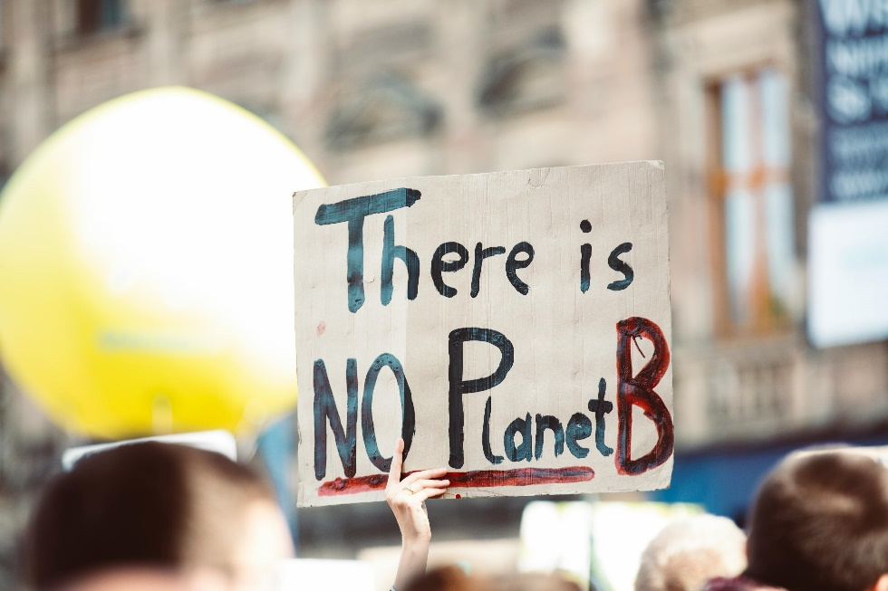

Darmstadt Forest / Germany 22.07. - 29.07.2024
An international training for youth activists: Community building as a key competence for political activities against global warming
Age: 18+ / Language: English
For active youth workers who want to learn and experience a concrete commitment to sustainability and climate justice at local and international level!
- Would you like to get to know people, initiatives, and their activities for climate justice?
- Would you like to gain an overview of the global problems caused by global warming and environmental pollution?
- Would you like to share your experience and practice with other international participants and their youth organisation and jointly develop new methods and approaches in the field of sustainability and the UN sustainability goals
- Would you like to learn together with international participants how to build local communities that take action against global warming and in favour of a sustainable lifestyle?
- Would you like to receive official recognition of your participation in this learning experience afterwards? (for more information: Youthpass).
If so, we would love to hear from you!
Global warming is a fundamental threat to all people on earth, but in different ways: The lifestyles of the rich are the main cause of the greenhouse effect, while people in the Global South suffer the most from the consequences such as drought, heatwaves and floods. Poor and young people in the North and South of the world in particular are bearing the consequences of a climate crisis that they did not cause.
The main focus of this training is local activism against global warming and for more climate justice. Activism is always strong, when it is supported by communities of people who trust each other and pursue a common goal. Together, we want to search for positive role models and helpful skills that can help us all achieve a more peaceful and sustainable future. The topics of community building, permaculture and experiencing nature will provide the framework for the training, which will consist of the following modules:
- Workshops on understanding global warming e.g. "climatefresk"
- Workshops on fair and sustainable nutrition e.g. "Food Justice"
- Workshops on community building as a nucleus for living utopias
- Visit to the rainforest centre "Centre for Global Sustainability" www.regenwaldzentrum.de
- Workshops on creative events and campaigns on the topic of climate justice
- Learning from best practice: Excursions to initiatives in Frankfurt that are committed to climate justice, e.g. Koala Kollektiv, Vegetable heroes with permaculture, fridays for future
Become part of the international movement for sustainability and part of a community that stands up against discrimination!
Bit by bit, we can steer the world in a more sustainable direction, where people and the climate come before profit. We can all help shape this change! Some experience in youth or non-formal political education is required. You are welcome to use the experiences and results of this project in your own work.
Around 25 young people and young adults from Europe and neighbouring countries are invited to the training.
We will try to offer a safe space that celebrates diversity and does not accept any type of violence or discrimination: Diversity wins and strengthens! We therefore particularly welcome applications from people who had to flee their countries, migrated and/or confronted racism, people with disabilities and/or people from other marginalised groups.

Conditions for participation according to Erasmus + regulations
- 1-3 participants per organisation, from following regions: EU- Europe, Eastern Europe, Caucasus, Mediterian regions
- Age: 18+ (no upper limit)
- Working language: English
- Date of arrival 22.07.24 - in the afternoon
- Date of departure 29.07.24 – in the morning
- Location: Darmstadt Forest near Frankfurt / Main (Germany)
- The Hosting Organization of this offer will organise the accommodation and covers the costs for accommodation and food
- Participation fee: we try to adjust the fee to the purchasing power in the different countries
Fee for participants from Germany, West and North - European countries: 40,-€
Fee for participants from South and East European countries: 20,-€
- Reimbursement of the travel expenses is calculated according to the flat rate of the ERASMUS + programme. We ask the participants to use sustainable means of transport.
- Here can find overview of conditions of participation
Distance | Grant /pax | Grant with green travel / pax
10-99 km | Max 28,- € | Max 56,- €
100-499 km | Max 211,- € | Max 285,-€
500 -1999 km | Max 309,-€ | Max 417,-€
2 000 – 2999 km | Max 395,- € | Max 535,- €

Contact for questions:
Nikolaus Ell & Esma Tari
Youth Exchange , ICJA e.V. youthexchange@icja.de

